BEEHIVE ROCK & GEM CLUB TIME VALUE DO NOT DELAY
LINDA PILCHER, EDITOR FIRST CLASS MAIL
574 4TH ST
OGDEN, UT 84404

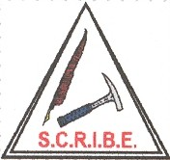
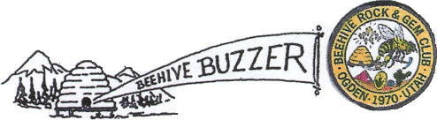

P.O. BOX 1011
OGDEN, UTAH 84402

VOL. 41 No.9 Website: http://www.beehiverockandgem.com Sept 2013
MEMBER OF UTAH FEDERATION OF MINERALOGICAL SOCIETIES
ROCKY MOUNTAIN FEDERATION OF MINERALOGICAL SOCIETIES
AMERICAN FEDERATION OF MINERALOGICAL SOCIETIES
The Beehive Rock & Gem Club began in April of 1970.
The purpose of our club is: To collect, cut and polish rocks, to gather fossils, mineral specimens, to discuss and impart our knowledge of the different phases of collecting, polishing and displaying-

To promote, organize and hold meetings, outings, trips, and similar events. To enjoy and protect our natural resources.

Permission to reprint from the BUZZER is granted if credit is given as from (the original bulletin if copied, then via “others" or “et all” for those between and then) BEEHIVE BUZZER with date of issue taken from.
USUAL DATE FOR MEETING - FOURTH THURSDAY - 7 PM at ROY MUNICIPAL CENTER MULTIPURPOSE ROOM 5051 S. 1900 W ROY, UT
November, December have changes. Maybe others.
Call any Board member for current information.
BEEHIVE ROCK AND GEM CLUB

September 2013

Beehive Buzzer

Volume 41 issue 9

BOARD OF DIRECTORS

OF THE BEEHIVE ROCK & GEM CLUB FOR 2010

President & Board Chair Dan Siler 801-737-3013
Vice President Steve Smith 801-731-4216
Secretary Dave Offret 801-791-6081
Treasurer David Law 801-731-4255
Field Trip Coordinator Roger Bush 801-775-0147
Program Chairman Ray Rutledge 801-732-8331
Door Prize Chair Jim Alexander 801-399-0785
Hospitality Chair Linda Pilcher 801-392-7620
Communications Kay Berry 801-825-6261
Membership Chair & Club Directory David Law 801-644-4931
Mini-show Chair Alice Crittenden 801-547-7781
Safety Chair Lynn Hayes 435-723-2216
Publicity Mark Acker 801-475-4705
Managing Editor of BUZZER Linda Pilcher 801-392-7620 Associate Leora Alexander 801-399-0785
Photographer Shari Bush 801-388-8605
Calling Committee Sherm & Ricky 435-760-1362
Thompson

(Deadline for BUZZER articles is the 2nd Thursday of the month)
Calling Committee ---- Need volunteers to call members before meetings.
6 people calling 6 others + 6 e-mailing 6 others!

FEDERATION REPRESENTATIVES DUES

Rocky Mountain Federation Delegate ----------------President Due: October 1
Utah Federation Delegate ------------------------------TBA Single - $11
Public Land Advisory Committee -------------------- Jim Alexander Couple or
Family - $16
Junior - $5
Overdue: January 1

Reminder: Club dues are due October 1. David Law is now accepting dues. Take care of it now so you do not have to worry about it later.

General Objectives of the Club


Meetings
General club meetings are held at 7 PM on the fourth Thursday of each month in the multi-purpose room of the City of Roy Municipal Center located at 5051 South 1900 West, Roy Utah.
News Letter
The Beehive Buzzer is the official newsletter of the Ogden Beehive Rock and Gem Club and is published eleven times per year. Please send your submissions and exchange bulletins to:
beehivebuzzer@gmail.com

Any material, in this bulletin
may be copied, unless marked as copyrighted. As long as credit is given to the originator or writer.

The purpose of our club is to stimulate interest in the collection of rocks, minerals, gem materials and legal fossils. To discuss and impart our knowledge of the different phases of collecting, cutting, polishing and displaying them. Also to organize educational meetings, field trips and similar events while enjoying and protecting our natural resources.

Membership Dues
Yearly membership dues for adult’s members are:
Single ………………. $11.00
Couple or Family…. $16.00
Junior (under 18, no family membership )...……..$5.00
Dues are due:
October 1 of each year.

In this Issue
Presidents Message…………….Pg 3
Up coming field trips…………..Pg 3
Upcoming Rock Shows………..Pg 3
Junior Members Corner………..Pg 4
Labor Day Field Trip…………..Pg 5
Sept Birthday Info……………..Pg 6
Funny did you knows………….Pg 6
Answers to Junior Members Corner
…………………………………Pg 7

FEDERATION REPRESENTATIVES CLUB AFFILIATIONS

Rocky Mountain Federation Delegate….President The Beehive Rock & Gem Club began in April
Utah Federation Delegate……………….Open of 1970 and is a member of the following:
Public Land Advisory Committee……...Jim Alexander
Utah Federation of Mineralogical Societies
ADVERTISING RATES: Rocky Mountain Federation of Mineral-
Logical Societies
For sale ads are permitted for members at no American Federation of Mineralogical
charge. Business advertisements will be charged at Societies Scribe
the rate of $5.00 for ¼ page or 15 cents per word for
less than ¼ page.

PRESIDENTS MESSAGE

The President stated that he did not have anything to say last minute for me but will try to catch him earlier
next time. He did suggest I remind everybody about this months meeting was canceled because of VOTING.

2013 Field Trip Schedule

Albert Creek (1day) Aug. 21st
Floy Wash Oct. 11-14th
Henry’s Mountain ?

Please, remember to RSVP Joe Kent for Floy Wash/ Henry’s Mt
Up coming shows:

Tooele Gem and Mineral
Sept. 27-29
400 N. 400 W.
Tooele, UT 84074

Richfield Rock Fossil & Mineral
Sept, 28-28
410 East 200 South
Richfield UT

Mineral Collectors of Utah
Sept. 27-29
Trolley Square
5th S. 6th E.
Salt Lake City UT

Moab Rock Show
Oct. 12-13
Old Spanish Trail Arena
3641 S Hwy 191
Moab, UT

R.O.C.K. Show
Oct 25-27
Larry Miller Campus
9750 South 300 West
Salt Lake City, UT



PLEASE REMEMBER!!!

This month the Beehive Rock Club Meeting has been CANCELED due to Election.

Junior Members Corner

By Oracle Think Quest Educational Foundation
Project by Students for Students

Did you know that the diamond is the hardest natural substance found on earth?
Did you know that quartz is one of the most common minerals on Earth?
Did you know that marble forms from metamorphosed carbonate rock, most usually limestone?
Did you know that basalt is the most common rock on Earth?
Did you know that breccia is a rock composed of generally large, sharp fragments cemented together?
Did you know feldspars make up more than 50% of the Earth's crust?
Did you know the first recorded use of turqouise dates back to 5000 BC in Mesopotamia, where people used the gemstone to make beads?
Did you know lapis lazul is treasured for its rich blue color and is often used in jewelry? Did you also know that ancient Eqyptians used powdered lapis lazul as eye shadow?
Did you know jade because of it's toughness has been used for many cultural things like hammers, fish hooks, and stone axes.
Did you know that rubies are one of the most popular gemstones today.

What is a Mineral?

Kidsloverocks.com

- Inorganic, which means that it is not
made by a living organism.

- A solid. There is one unusual exception.
Native mercury is a mineral and is the
only metal that is a liquid at normal
temperatures. Has a regular crystal
structure. The crystal structures are
described as crystal systems.

- Made by nature which means minerals
are not made, directly or indirectly,
from human activity.

- Has a predictable chemical formula.

Which of the following are minerals?

- Cubic Zirconia
- Diamond
- Fluorite
- Galena
- Graphite
- Ice Cubes
- Pyrite (“Fool’s Gold”)
- Ruby
- Snow

Answers on last page of Newsletter Pg7.

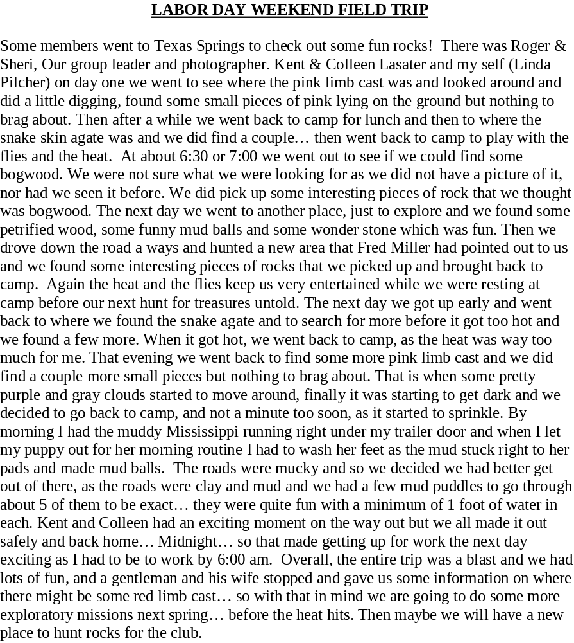

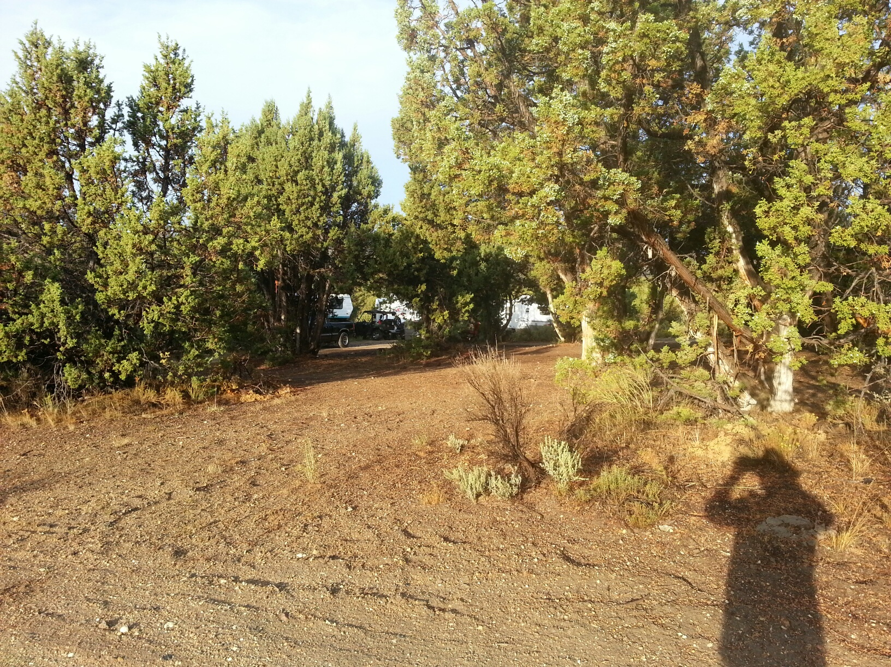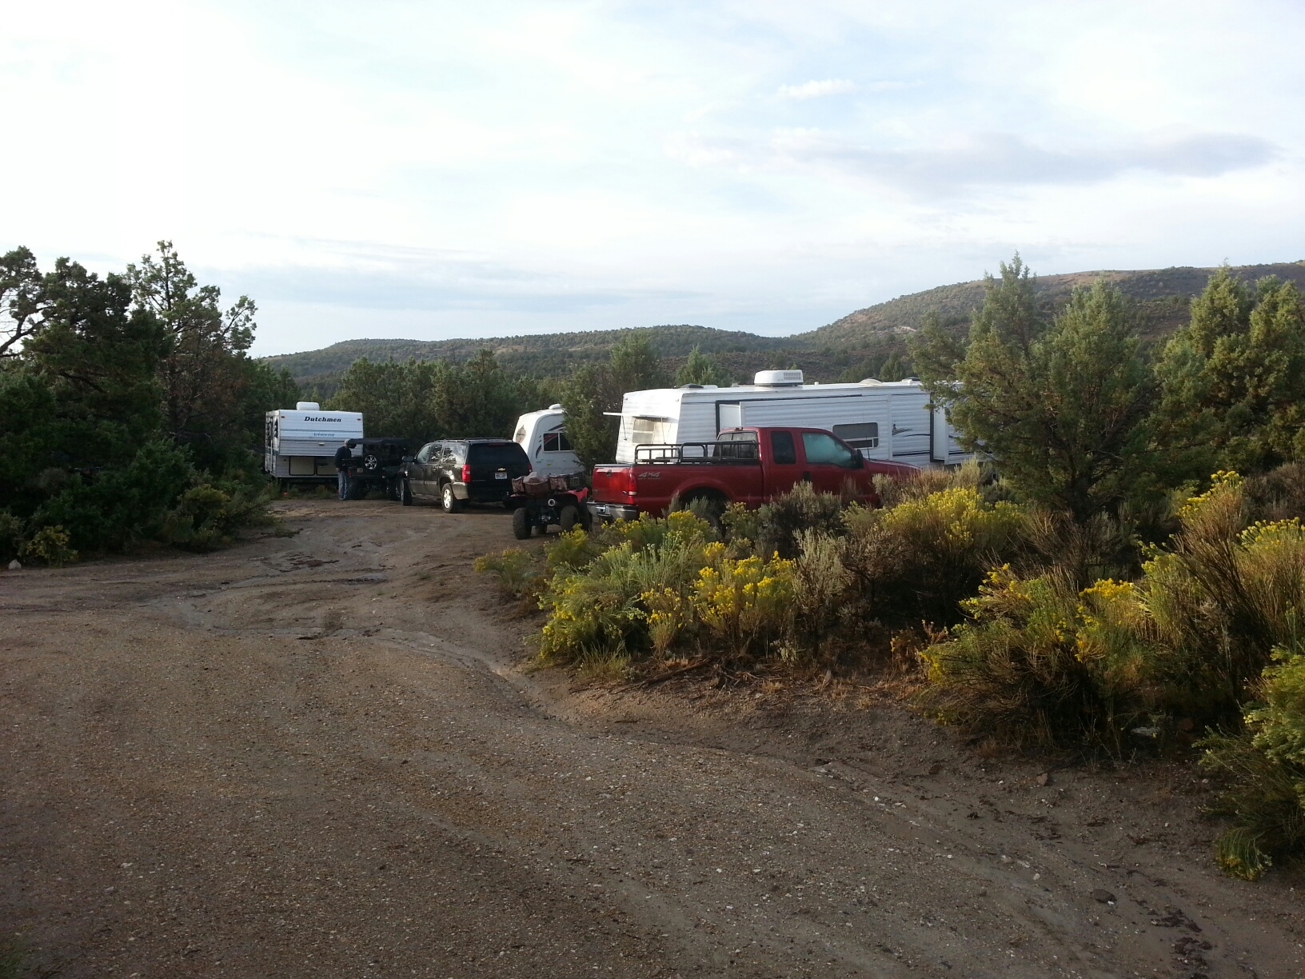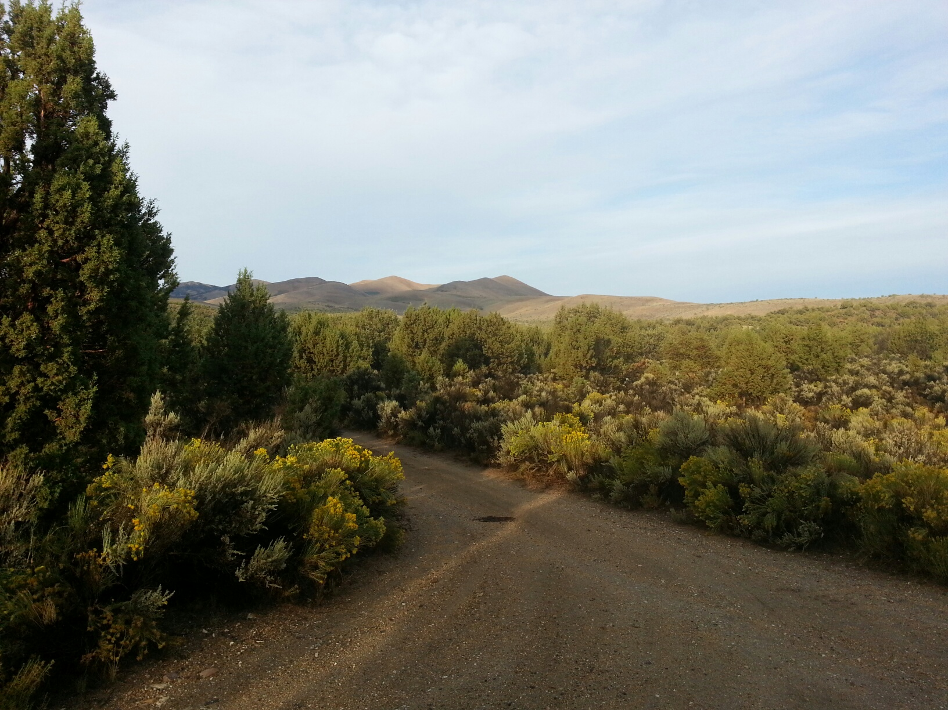
SEPTEMBER
Birthstone

By Trinity Tailing s 9/92
and Magic Valley Gem News 2001

Sapphire for Truth, Purity, and clear thinking; When combined with iron and titanium, the sapphire is formed. Sapphire is blue corundum as well as all other colors except the reds, which are rubies. The most highly prized are Cornflower blue with a soft velvet luster. Some which contain inclusions of rutile, giving a “Star” effect are made into cabochons, but most are faceted. Parent rocks eroded in ancient times and the gem minerals were carried by streams in beds of gravel, later to be buried by soil. Gems are mined by hand Methods, with prized materials from Sri Lanka (Ceylon), Burma, Thailand, Cambodia, India and Austrailia.They occur in metamorphic rocks Sapphires have a hardness of 9 On the scale of Mohs...

Funny did you knows??

You might be a geologist if...............

You can pronounce the work “molybdenite” correctly on the first try.

You think the primary function of road cuts is a fun tourist attraction.

The rock pile in your garage is taller than you.

The local university's geology department requests permission to hold a field trip in your back yard.

Your children are named Rocky, Jewel or Beryl.

When the baggage handlers know you by name and refuse to help you with your luggage.

Or

When you receive a letter from the city informing you, that you need a land fill permit for your rocks.



